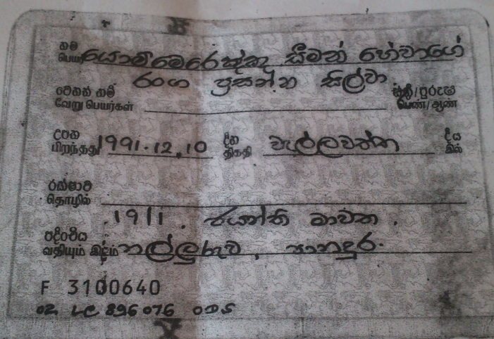

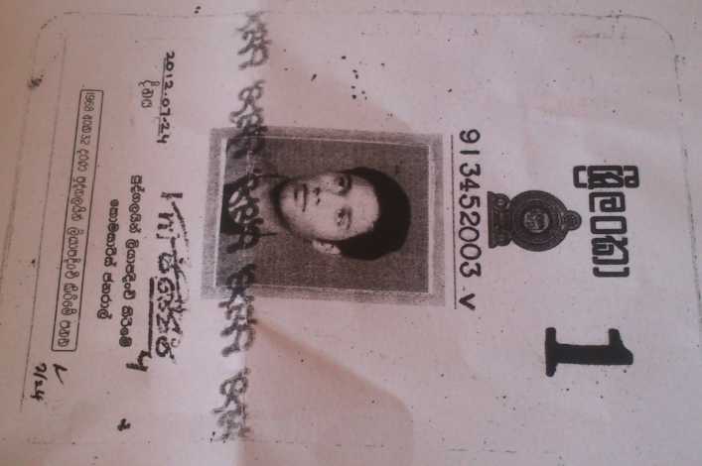

8994035150914954670



8994035150914954639

Name : Yommerengngnu Seeman Hewage Ranga Prasanna Silva

Address : 19/1 Jayanthi Mawatha, Nallaruwa, Panadura

ID no : 913452003v

Etisalat NOs – 0727824224, 07278224 42

Contact No : 0787679159